PES University
Software Engineering Lab -01
Name: K Rishith Section:D
SRN: PES1UG24CS207
- Requirements Table:
ID | Type / Priority | Description | Acceptance Criteria | Rationale
FR-001 | High | The system shall compute triage severity scores from intake vitals and dynamically order the ER bed allocation waitlist. | Pass: Higher acuity patient automatically moves ahead of lower acuity patient. Fail: FIFO queue ignores critical emergency. | Ensures the most critical patients receive care first, adhering to medical triage protocols.
FR-002 | High | The system shall display a real-time dashboard of all ER and ICU bed statuses (Available, Occupied, Cleaning, Maintenance). | Pass: Dashboard reflects status changes instantly without manual page refresh. Fail: Staff sees outdated bed availability. | Allows administrators and nurses to make immediate routing decisions based on accurate capacity.
FR-003 | High | The system shall allow the Triage Nurse to assign a waitlisted patient to an "Available" ER or ICU bed. | Pass: Patient is removed from waitlist and linked to the specific bed; bed status changes to "Occupied." | Core operational function for admitting patients and tracking who is where.
FR-004 | Medium | The system shall allow authorized users to initiate an inter-facility ambulance transfer workflow for a patient if local ICU beds are full. | Pass: User can select a patient, select a destination facility, and generate a dispatch request. | Necessary for orchestration of care when local hospital capacity is exceeded.
FR-005 | Medium | The system shall allow Hospital Administrators to generate daily ward occupancy and transfer volume reports. | Pass: Administrator can export a PDF/CSV showing peak occupancy times and transfer counts. | Required for capacity planning, staffing adjustments, and operational auditing.
NFR-001 | Performance | Bed status transitions (Occupied, Cleaning, Available) must propagate to all connected dashboard clients in under 1 second via WebSockets. | Pass: Benchmarking tests confirm target latency and security standards under simulated peak load. | Real-time accuracy is critical in emergency settings; delays could cause double-booking of beds.
NFR-002 | Security | The dashboard must enforce Role-Based Access Control (RBAC), ensuring only authorized clinical staff can view Patient Protected Health Information (PHI). | Pass: An administrator account cannot view patient intake vitals, while a triage nurse account can. | Strict compliance with HIPAA (or local healthcare data laws) is mandatory for hospital software.

- UML Use-Case Diagram:

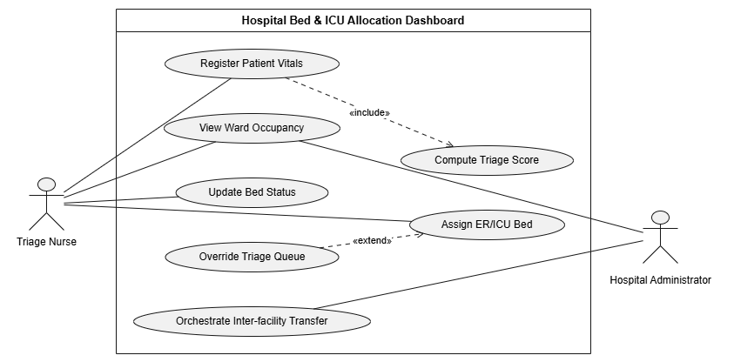

- Use Case Flow Specification:

Use Case Name: Assign ER/ICU Bed Primary Actor: Triage Nurse Goal: To allocate an available bed to the highest-priority patient on the triage waitlist.
Preconditions:
- The Triage Nurse is authenticated and logged into the dashboard.
- The patient has been registered, vitals entered, and a triage severity score computed.
- The patient is currently on the active waitlist.
Postconditions:
- The patient is removed from the waitlist.
- The selected bed's status is updated to "Occupied".
- The real-time dashboard broadcasts the updated capacity to all connected clients.
Main Success Scenario:
- The Triage Nurse views the "Dynamic ER Waitlist" on the dashboard.
- The system displays the waitlist, ordered descending by Triage Severity Score.
- The Triage Nurse selects the patient at the top of the queue.
- The system highlights all beds currently marked as "Available" on the ward map.
- The Triage Nurse clicks on an "Available" bed to assign the patient.
- The system prompts for confirmation of the assignment.
- The Triage Nurse confirms.
- The system links the patient ID to the Bed ID, updates the bed status to "Occupied," and removes the patient from the waitlist.
Alternate Flow 1: No Available Beds (Triggering Inter-facility Transfer)
- At Step 4: The system determines there are zero beds marked "Available" in the required ward (e.g., ICU).
- 4a. The system displays an "ICU at Capacity" alert and grays out the ward map.
- 4b. The system prompts the Triage Nurse to initiate an "Inter-facility Ambulance Transfer."
- 4c. The Triage Nurse selects "Initiate Transfer."
- 4d. The system branches to the Orchestrate Inter-facility Transfer use case, alerting the Hospital Administrator and generating an ambulance dispatch request.

